**BGSSN Supplementary material**

**Supplementary Table 1.** Known associated genes of breast cancer

|  |  |  |  |  |
| --- | --- | --- | --- | --- |
| Gene name | | | | |
| ACTB | CD24 | CYP19A1 | HRAS | PIK3CA |
| AKT1 | CD274 | EGF | IGF1R | PTEN |
| ANXA5 | CD4 | EGFR | IL6 | SNAI1 |
| AR | CD44 | ERBB2 | KRAS | SNAI2 |
| ATM | CD8A | ERBB3 | MAPK3 | SRC |
| BCL2 | CDH1 | ESR1 | MMP9 | STAT3 |
| BRCA1 | CDH2 | ESR2 | MUC1 | TNF |
| BRCA2 | CDK4 | FN1 | MYC | TP53 |
| CASP3 | CHEK2 | GAPDH | NOTCH1 | VEGFA |
| CCND1 | CTNNB1 | HIF1A | PGR | ZEB1 |

**Supplementary Table 2.** New breast cancer-associated genes of different subtypes

|  |  |  |  |
| --- | --- | --- | --- |
| Basal | Her2 | LumA | LumB |
| RAB7A | RAB7A | RAB7A | RAB7A |
| RGPD3 | RGPD3 | RGPD3 | RGPD3 |
| ANKHD1 | ANKHD1 | ANKHD1 | ANKHD1 |
| GHITM | RABGEF1 | GHITM | RABGEF1 |
| RABGEF1 | GHITM | RABGEF1 | GHITM |
| BBS1 | BBS1 | BBS1 | BBS1 |
| ZNF23 | ZNF23 | ZNF23 | ZNF23 |
| ACAD11 | ACAD11 | HNRNPF | ACAD11 |
| HNRNPF | HNRNPF | ACAD11 | HNRNPF |
| RGPD1 | TOMM6 | TOMM6 | TOMM6 |
| TOMM6 | RGPD1 | RGPD1 | RGPD1 |
| ZNF709 | CYB5D1 | CYB5D1 | ZNF709 |
| YWHAB | ZNF709 | ZNF709 | EEF1G |
| ATRIP | ATRIP | YWHAB | CYB5D1 |
| CYB5D1 | EEF1G | EEF1G | DDOST |
| CANX | YWHAB | ATRIP | ATRIP |
| EEF1G | DDOST | CANX | YWHAB |
| RAG1 | RAG1 | RAG1 | RAG1 |
| SNX15 | RAB43 | SNX15 | CANX |
| PIK3R2 | CANX | RAB43 | PIK3R2 |
| RAB43 | PIK3R2 | PIK3R2 | RAB43 |
| DDOST | RPSA | MSMP | ASB3 |
| ASB3 | MSMP | DDOST | RPSA |
| MSMP | SNX15 | RPSA | SNX15 |
| ZNF208 | ASB3 | ASB3 | MSMP |
| ZNF410 | SYN2 | ARF1 | ARF1 |
| RPSA | ZNF410 | HSP90AB1 | ZNF410 |

**Supplementary Table 2.** (continued)

|  |  |  |  |
| --- | --- | --- | --- |
| Basal | Her2 | LumA | LumB |
| ZNF490 | ZNF490 | ZNF208 | ZNF208 |
| ARF1 | ARF1 | ZNF410 | SYN2 |
| SYN2 | ZNF208 | HSP90AA1 | ZNF490 |
| C1orf43 | C1orf43 | C1orf43 | GTF2IRD2 |
| TOMM20 | HSP90AB1 | GTF2IRD2 | TOMM20 |
| GTF2IRD2 | GTF2IRD2 | SYN2 | HSP90AB1 |
| HSP90AA1 | TOMM20 | ZNF490 | C17orf49 |
| TNXB | HSP90AA1 | TOMM20 | SCHIP1 |
| C7orf25 | C17orf49 | EIF5AL1 | EIF3CL |
| C17orf49 | SCHIP1 | C7orf25 | C7orf25 |
| SCHIP1 | C7orf25 | SCHIP1 | EIF5AL1 |
| HSP90AB1 | EIF5AL1 | EIF3CL | C1orf43 |
| EIF3CL | EIF3CL | C17orf49 | HSP90AA1 |
| NPHP3 | NPHP3 | NPHP3 | NPHP3 |
| EIF5AL1 | JTB | RGPD5 | RGPD5 |
| RGPD5 | SARM1 | JTB | JTB |
| BTF3 | U2AF1 | ATF4 | U2AF1 |
| GTF2H2C | TNXB | EIF3I | EIF3I |
| U2AF1 | RGPD5 | **YWHAH** | SARM1 |
| JTB | EIF3I | **APEX1** | GPS2 |
| SARM1 | GTF2H2C | EIF5A | ATF4 |
| **PIGT** | GPS2 | SARM1 | **DDX47** |
| **CCNI** | BTF3 | U2AF1 | EIF5A |

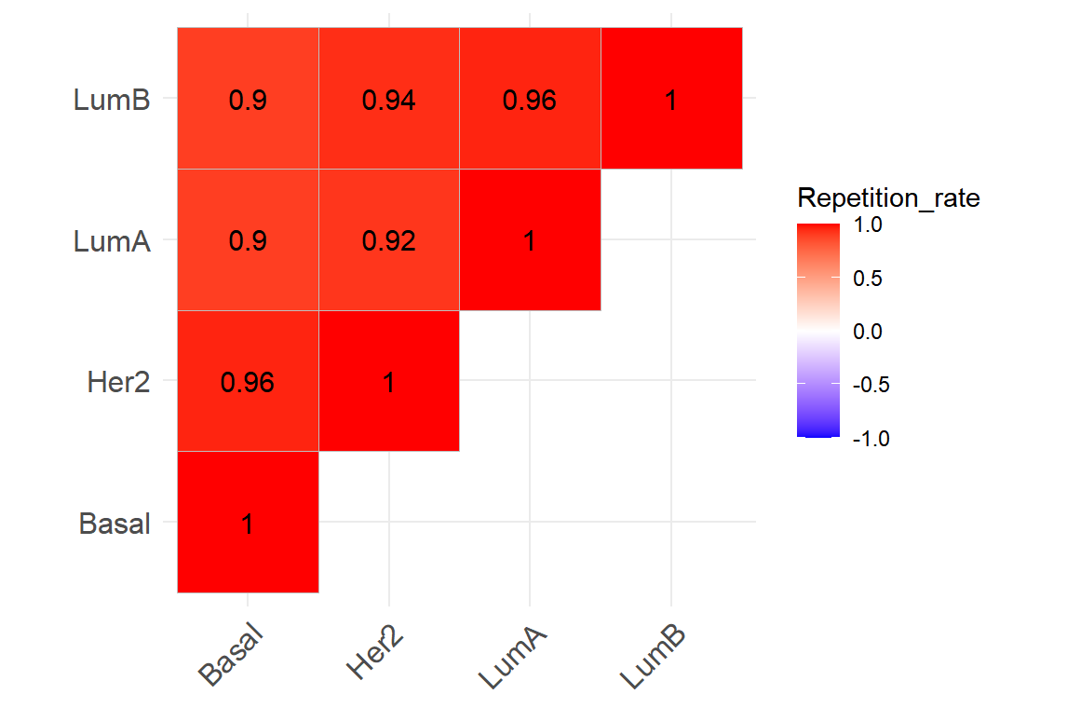

**Supplementary Figure S1.** BGSSN predicts the duplication rate of genes associated with different subtypes of breast cancer.

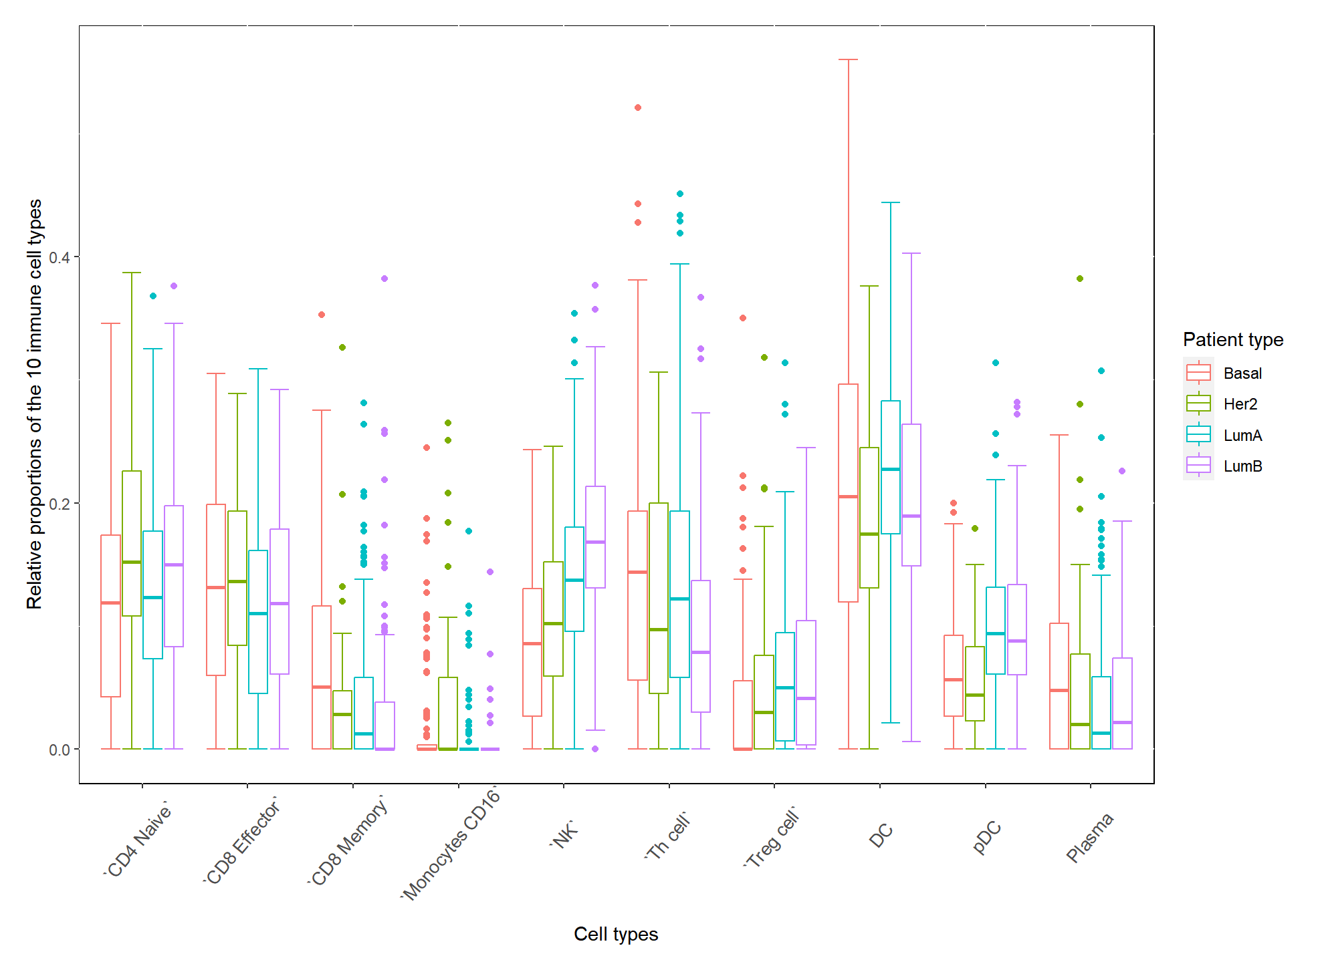

**Supplementary Figure S2.** The proportion of ten immune cells in different of breast cancer subtypes.